

**SCHOOL OF SCIENCE**

**DEPARTMENT OF MATHEMATICS AND COMPUTER SCIENCE**

**BACHELOR OF INFORMATION TECHNOLOGY**

**COURSE CODE: BITC 416**

**PROJECT CORE**

**COVID-19 CASES TRACKER**

**SUBMITTED BY**

CLINTON RUMBANI MAKORI

ADM NO: BIT/011/17

**Name of the supervisor:**

MADAM LILY SIELE

**THIS PROJECT DOCUMENTATION IS SUBMITTED TO THE DEPARTMENT OF MATHEMATICS AND COMPUTER SCIENCE, UNIVERSITY OF ELDORET (UoE), IN PARTIAL FULFILMENT OF THE REQUIREMENTS FOR THE AWARD OF DEGREE IN BACHELOR OF SCIENCE IN INFORMATION TECHNOLOGY**

# DECLARATION

This is to certify that this Report entitled DESIGN AND DEVELOPMENT OF COVID 19 CASES APPLICATION TRACKER, which is submitted by CLINTON RUMBANI in partial fulfilment of the requirement for the award of degree for Bachelor of science in Information Technology to the Department of Mathematics and Computer Science, UNIVERSITY OF ELDORET is a record of the candidate’s own work carried out by the candidate under my own supervision. The matter embodied in this thesis is original and has not been submitted for the award of any other degree within this institution to my own belief and to the best of knowledge.

**APPROVED BY:**

**SUPERVISOR: MADAM LILY SIELE**

**Signature: …………………………………………………………….**

**STUDENT’S NAME: CLINTON RUMBANI**

**Signature:……………………………………………………………..**

# DEDICATION

This work is dedicated to God Almighty, my strong pillar, my source of inspiration, wisdom, knowledge and understanding. He has been the source of my strength throughout this program.

This work is also dedicated to my parents, my lecturers through my course of study and as well to my supervisor MADAM SIELE for full support throughout the design and development.

Thank you all for your support. God bless you.

# ABSTRACT

This application presents a Covid-19 cases tracker system where anyone referred to as users within this system can load information about covid cases for Kenya, for the World and also for each country. This enables you to keep track of covid cases on a country base level and also on a world base level. The application uses a minimalistic user-friendly interface. Thus, making the users comfortable with using the application. The application derives its data from a JSON (JavaScript Object Notation) which is updated twice a day. Thus offers a level of accuracy in the representation of the data. A user can access the data whenever they want as long as they have an Android Mobile phone with the application installed that has internet access anytime of the day.

# TABLE OF CONTENT

Table of Contents

DECLARATION i

DEDICATION ii

ABSTRACT iii

TABLE OF CONTENT iv

LIST OF FIGURES v

CHAPTER 1 1

1.0 INTRODUCTION 1

1.1 BACKGROUND AND MOTIVATION 1

1.1.0 BACKGROUND STUDY 1

1.1.1 Motivation 2

1.2 PROBLEM STATEMENT 2

1.3 AIMS AND OBJECTIVES 3

1.4 JUSTIFICATION 3

1.5 SIGNIFICANCE OF THE APPLICATION 4

Project Risk Assessment 4

Scope/Project Organization 5

CHAPTER 2 6

LITERATURE REVIEW 6

2.0 INTRODUCTION 6

2.1 SYSTEM REVIEW 6

Summary 9

CHAPTER 3 10

3.0 SYSTEM DESIGN AND ANALYSIS 10

3.1 INTRODUCTION 10

3.2 DEVELOPMENT APPROACH 10

3.3 FACT FINDING APPROACH 10

3.4 REQUIREMENT ANALYSIS 12

3.5 LOGICAL DESIGN 12

CHAPTER 4 17

4.0 METHODOLOGY 17

4.1 INTRODUCTION 17

4.2 AGILE METHODOLOGY 17

CHAPTER 5 20

5.0 IMPLEMENTATION 20

5.1 IMPLEMENTATION ENVIRONMENT 20

5.2 NETWORK IMPLEMENTATION 21

5.3 SYSTEM SECURITY 21

CHAPTER 6 22

6.0 EVALUATION 22

6.1 TESTING STRATEGIES 22

CHAPTER 7 26

7.0 FUTURE ENHANCEMENTS, RECOMMENDATIONS AND CONCLUSION 26

7.1 FUTURE ENHANCEMENTS 26

7.2 RECOMMENDATIONS 26

7.3 CONCLUSIONS 26

7.4 LESSON LEARNT 27

REFERENCES 28

CHAPTER 8 29

# LIST OF FIGURES

Figure 1 Johns Hopkins University Center for Systems Science and Engineering dashboard 7

Figure 2 World Health Organization Dashboard 8

Figure 3: Jitenge MoH Kenya app Figure 4: Jitenge MoH ussd 9

Figure 5 Use case diagram 13

Figure 6 Context level diagram 14

Figure 7 Activity Diagram 15

Figure 8 Entity relation diagram 16

Figure 9 Agile Methodology Diagram 17

Figure 10 Splash screen 29

Figure 11 Registration 30

Figure 12 Login 31

Figure 13 Kenya's dashboard 32

Figure 14 About 32

Figure 15 World's dashboard 33

Figure 16 Search cases data 35

# CHAPTER 1

## INTRODUCTION

Since the outbreak of COVID-19, public reporting of pandemic-related indicators such as new cases, death counts, and testing rates has surged. This heightened level of activity attests to the core function of governments to protect the public’s health and safety as well as their critical role of providing information to achieve this end. The uses and advantages include enabling international comparisons, monitoring and improving the quality of care, fostering accountability and transparency empowering the public to form an opinion on and build trust in their government’s response and supporting individuals to make informed, risk-minimizing behaviour changes. Thus, the internet being one of the most innovative communication tools became the Center stage for the basis of availing Covid related information to a larger population. One of which is the primary objective of this project which is all about delivery of accurate real-time data to the hands of users.

## 1.1 BACKGROUND AND MOTIVATION

### 1.1.0 BACKGROUND STUDY

This project was carried out to fulfil the final year project requirement at the same time delivering a fully functional android application to deliver Covid-19 case updates to Kenyans. I preferred to develop an Android based application to satisfy the need for mobility and accessibility.

The existing ways to get updates on covid cases in Kenya is through the media: Television, Radio, Social Media platforms such as twitter and the Web. Thus, the existing system of getting updates is limited by the following problems:

* In the case of television, updates are only given during News update timelines which means that one has to wait until the news is presented and as for Kenya update are given live at 1500hrs.
* Television and Radio do not offer the capability of viewing and comparing data from other countries and the world on a regular basis.
* Social media platforms may give inaccurate information due to the freedom of social media users in posting information as a freedom of speech.
* The Web provides dashboards which are more reliable in terms of accuracy and real-time update but it takes a lot of time to load all the data while using a laptop or a desktop and even longer when using a mobile phone.

### 1.1.1 Motivation

In consideration with the current ways of disseminating Covid-19 cases, the way the information is distributed today is quite problematic and unreliable thus, this android application is developed to provide the solution and also provide reliability using statistics to provide a better understanding of the current Covid-19 situation.

## 1.2 PROBLEM STATEMENT

The most prominent way of accessing COVID-19 cases data in Kenya is by the media which is costly to organize press conferences every single day. In addition to that not all Kenyans have access to a television. Press conferences are also time consuming especially in organizing all the media company representatives in one place. The data is also manually read by Cabinet Secretary for Health Hon. Mutahi Kagwe or a representative from his office. Moreover, the data presented is only statistically related and constrained to Kenya thus, little room for carrying out comparisons with other countries to determine the current state of Kenya in relation to Covid -19 related cases.

I decided to come up with this application to overcome these challenges and to provide reliability. The advantages of this application include:

* Users will be in a position to get accurate regular updates as soon as they are announced.
* Enhance understanding of the statistical data through comparisons.
* Provide reliability and flexibility.
* Efficient to users who wish to get timely updates concerning Covid-19 cases.

## 1.3 AIMS AND OBJECTIVES

From the above-mentioned problems, the aim is to develop and android based application that will help in addressing the ongoing issues from the current way of disseminating information and help in the facilitation of the task of disseminating information to the public at an easy, convenient, reliable and cost-efficient ways of disseminating information.

Specific objectives are:

* To study the current ways of disseminating Covid-19 related cases.
* To identify the challenges in the current ways of disseminating covid-19 statistical data to the public.
* To design and develop a simple android application to monitor, analyze and disseminate information to its user in a reliable way.
* To design a user-friendly system that enables users to check for regular updates on Covid-19 cases for Kenya, the World and for the desired individual country.

## 1.4 JUSTIFICATION

The Application will:

* Ease the access of Covid-19 cases information.
* Allow for easier comparison of cases, deaths and recovery for each country.
* Easy access of daily recorded cases.
* Display a visual output of the cases to create a more statistical understanding.

## 1.5 SIGNIFICANCE OF THE APPLICATION

Projects provide a flexible framework for engaging students in exploring curricular topics and developing important skills, such as communication, teamwork, and technology skills.

The application promotes easy access of covid cases thus creating efficiency and reliability in the flow of information compared to traditional ways of dissemination of information. The application in itself promotes the use technology in the fight against diseases.

Also, it would help students and researchers that are working actively towards enhancing the Covid-19 case tracker, this would serve as a reference to them as they strive to develop more disease related trackers in the future.

### Project Risk Assessment

#### Table 1 Risk and Prevention

|  |  |
| --- | --- |
| RISK | PREVENTION |
| Loss of power | There is likelihood of loss of power when working on the project. To avoid that, the laptop used last for nearly five hours which is good enough between the times taken to bring back the light. |
| Inability to carry out research due to loss of hardware or software resources | Required hardware will be bought instantly while relevant software that may likely be lost will be kept in the computer for easy repair or reinstallation. |
| Loss of work due to equipment failure /loss | Weekly data backup to portable hard drive |
| Lack of Internet access | To prevent lack of internet access, two means of internet access was provided purposely for this project, which is accessing from free WIFI network provided by university and through use of paid services to buy internet bundles |

## Scope/Project Organization

The main aim of this project is to develop an Android Covid-19 case Tracker to support in the dissemination of Covid-19 cases information. The application is mainly targeting the Kenyan population. At this stage of development, the project will be launched using Firebase real-time database which is a flexible database for android applications.

# CHAPTER 2

## LITERATURE REVIEW

### 2.0 INTRODUCTION

Literature review is the evaluation of information found in existing literature that bears relation to a selected area of study. It is an assessment of the existing literature and systems. Since the onset of the Covid-19 pandemic different types of systems have been developed all over the world to aid in the fight against Covid-19. However, in Kenya Little focus has been developed to use technology to assist in tackling issues concerning the pandemic. With a view of developing a better system, review of the existing literature and systems must be done so as to source information on their functionality. This involves identifying the functionalities of various modules of the existing systems so as to gain the basic idea of developing a system dynamic enough to compete strongly in the market. Information fetched is of great value and significance.

### 2.1 SYSTEM REVIEW

This research is important to compare requirements and advantage of the system with what exists around that is why researcher has chosen to review a few examples of the systems which are related to the leave management services. The Literature focuses on Covid-19 information dissemination system in other parts of the world. Some of the systems include:

1. Johns Hopkins University Centre for Systems Science and Engineering dashboard.
2. The World Health Organization dashboard.
3. Jitenge system.

#### 2.1.1 Johns Hopkins University Center for Systems Science and Engineering dashboard (JHUCSSE).

The JHU CSSE dashboard’s interactive map locates and tallies confirmed infections, fatalities and recoveries. Graphs detail virus progress over time. Viewers can see the day and time of the most recent data update and data sources. The dashboard’s five authoritative data sources include World Health Organization (WHO), US Centres for Disease Control and Prevention, National Health Commission of the People’s Republic of China, European Centre for Disease Prevention and Control, and the Chinese online medical resource DXY.cn. The dash board provides links to these sources and others. Web services allow GIS users to consume and display disparate data inputs without central hosting or processing to ease data sharing and speed information aggregation. In the first dashboard iteration, from January 22 through January 31, 2020, the Hopkins team manually updated data twice per day.

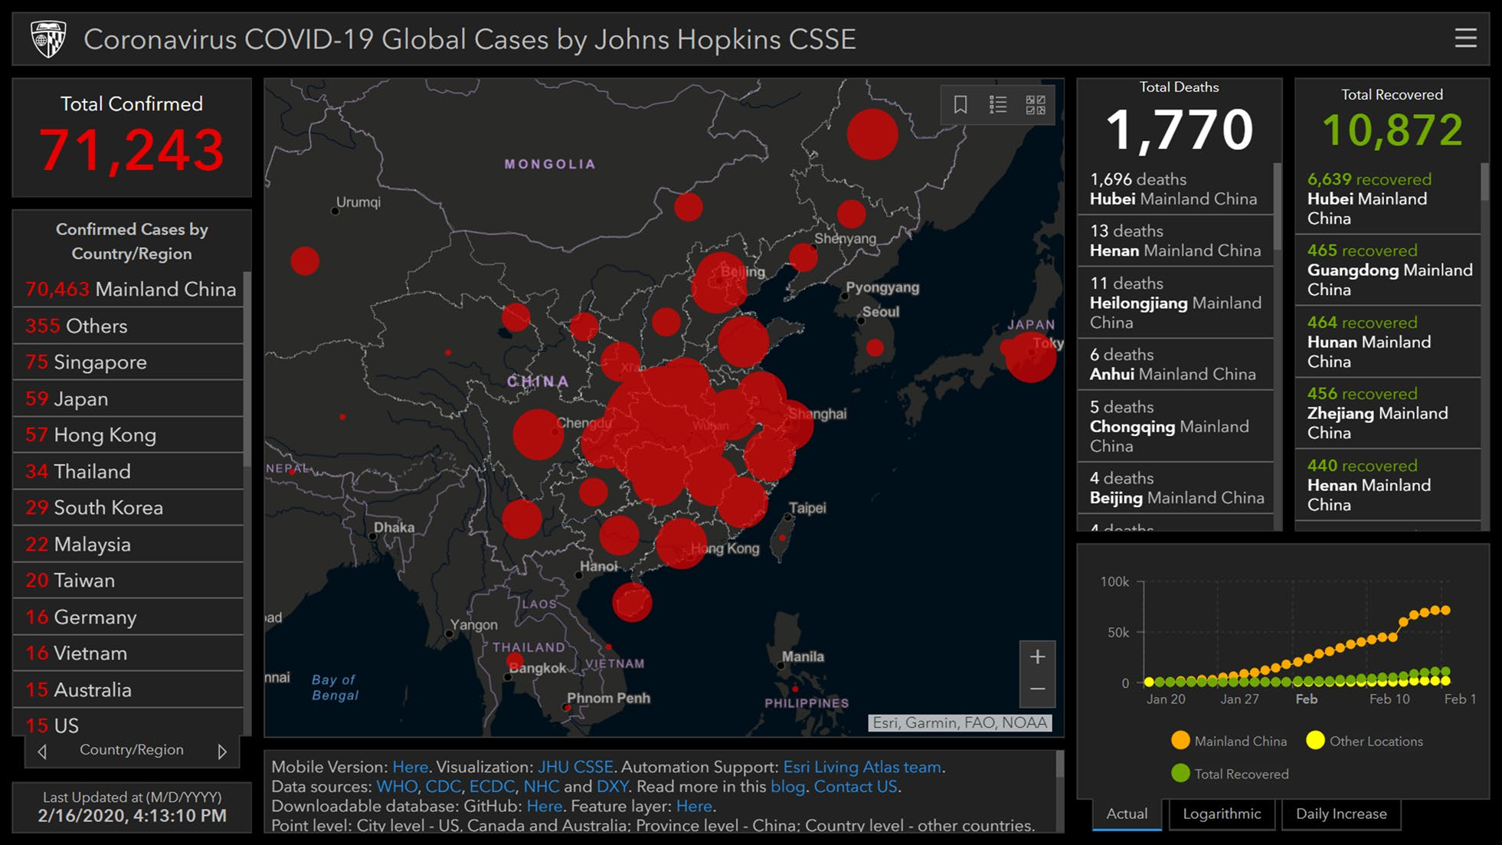

Figure 1 Johns Hopkins University Center for Systems Science and Engineering dashboard

#### 2.1.2 The World Health Organization dashboard

The WHO directs and coordinates international health, combating communicable diseases through surveillance, preparedness and response, and applying GIS technology to this work. On 26 January 2020, the WHO unveiled its ArcGIS Operations Dashboard for COVID-19, which also maps and lists coronavirus cases and total number of deaths by country and Chinese province, with informational panels about the map and its data resources (Fig. 2).

The WHO is updating its COVID-19 dashboard automatically using ArcGIS Geo Event Server to push updates to a single feature service multiple times per day. The WHO dashboard optimization measures include moving tiled data off its server and into ArcGIS Online tiled services to benefit from Esri’s content delivery network.

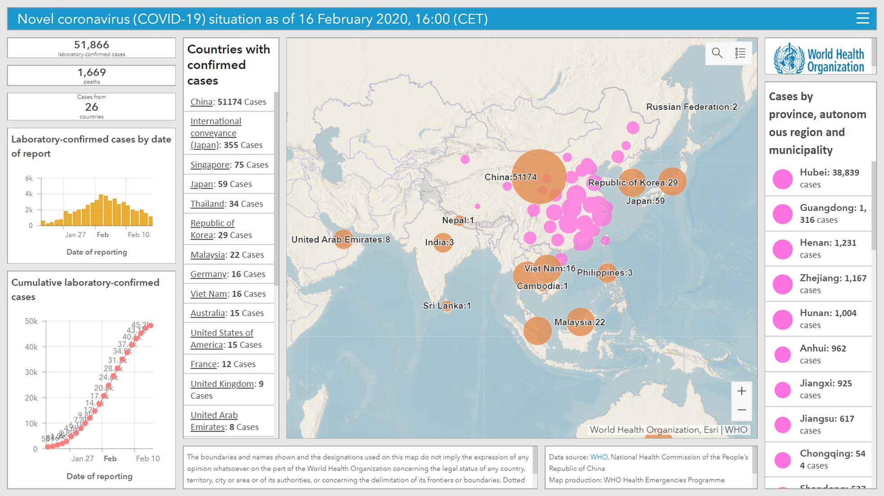

Figure 2 World Health Organization Dashboard

#### 2.1.3 Jitenge System

Jitenge, a Swahili word for self-isolate, is an innovation of mHealth Kenya developed to support the Government in the fight against COVID-19 in Kenya. The Jitenge solution was developed as a module of the Emergency Alert and Reporting System (EARS) used by the Ministry of Health’s Emergency Operations Centre (EOC) to respond to over 40 infectious diseases. The EARS system was also developed by mHealth Kenya.

Jitenge is available as an Android Mobile Application – Jitenge MOH, a USSD session - *299#, and an interactive web-based platform that supports a dynamic dashboard.

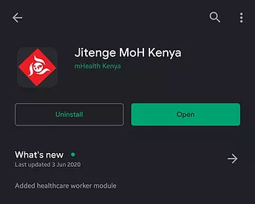 

Figure 3: Jitenge MoH Kenya app Figure 4: Jitenge MoH ussd

Jitenge allows users to either self-register or are registered by various Ministry of Health officials at the quarantine initiation point for home quarantine, at the quarantine facilities, and of the point of entries by port health officials.

Registered users will then receive daily reminders and prompts to report on their health status including symptoms or any other information. The system is being used to manage and monitor the following;

1. Home based care management
2. Self-quarantine for contacts
3. Post-isolation follow-up
4. Monitoring of long-distance truck drivers

## Summary

This chapter shows us the role played by technologies in the fight against Covid -19 pandemic. On the onset of Covid-19 online dashboards took the center stage as a means of providing information on Covid-19 cases. Although the information is not completely real time due to factors like different world time zones and different reporting times of cases in individual countries, dashboards have provided the best possible solution to disseminate information related to Covid-19.

# CHAPTER 3

## SYSTEM DESIGN AND ANALYSIS

### INTRODUCTION

This research is aimed at developing an android application which is a useful tool in the fight against Covid-19 pandemic through the dissemination of cases from all over the world. The application derives the information on a daily basis from a JSON file and organizes the data in text views creating a statistical structure which is helpful in comparisons and making decisions.

### 3.2 DEVELOPMENT APPROACH

#### 3.2.1 System Design

System design is the process of producing a design that would define specification of user requirements stated at the system analysis stage. This involves transforming the previously defined specifications into a design that approves the earlier analyzed requirements of the system.

### 3.3 FACT FINDING APPROACH

#### 3.3.1 Research Design

A research design is the plan and structure that outline what should be done from writing hypothesis to final data analysis. The Research design employed is experimental design which is undertaken to better comprehend the nature of this problem. Hakim, C. (2010).

**Experimental Research Design**

Experimental research is one which employs objective, systematic and controlled investigation for the purpose of predicting, controlling and examining probability and causality among selected variable (Johnson & Turner, 2007). The researcher should have background knowledge of how the system works and understands the points of the current manual system. The researcher has to collect some data from the already existing systems while implementing. In the development phase, after the system is ready it is then tested to see whether it meets the required standards and an improvement made, when necessary, then given to a few other users to test if it functions as required. If it is found to meet requirements hence is implemented.

**Advantages of experimental design research**

1. As well as controlling the independent variable the experimenter attempts to eliminate unwanted extraneous variables.
2. Control over extraneous variables is usually greater than in other research methods.
3. Experimental design involves manipulating the independent variable to observe the effect on the dependent variable. This makes it possible to determine a cause-and-effect relationship.

#### 3.3.2 Population

The research has been carried out at the University of Eldoret. The targeted population is about 10,000 participants from the general public. The study comprises of members of the school including staff members and students.

#### 3.3.3 Sample and Sampling Techniques

The sampling technique used was stratified sampling where random sampling is done within stratum. Target population at the University of Eldoret is estimated to be total of over 10,000 members.

#### 3.3.4 Data Collection Technique

**Observation**

1. This involves getting the core idea on current fully functioning systems to checkout their problem and catch up on the requirements which were mentioned in other methods of data collection.
2. This method of observation is very useful to identify the workload other systems have when carrying out daily activities so as to work on developing a system that outcomes these problems.

### 3.4 REQUIREMENT ANALYSIS

Divided into categories; namely functional requirements and non-functional requirements. Functional requirements entail what the Covid-19 cases tracker would be doing in order to achieve its goals While non-functional requirements describe how the application would perform the functional requirements.

#### 3.4.1 Functional Requirements

1. **Registration –** The system is able to accept personal information such as the personal details, the phone number of the users and store it into the Firebase Real-Time database.
2. **Login –** The system is also able to allows users to authenticate themselves so as to access data.
3. **Processing-**The system is able process the data required by the user and avail the information to them.

#### 3.4.2 Non-functional requirements

1. **Security –** access control through login security and registration. Due to the administration and usage security to avoid intruders tapping and accessing the information that might be violated to the user’s private rights.
2. **User-friendly –** since the interface of the application contains links, menus, interfaces, which is comfortable enough to enable every targeted user to easily use it.

### 3.5 LOGICAL DESIGN

#### 3.5.1 Use Case Diagram

A Use Case Diagram is a graphical representation that describes how users would interact with the proposed system. It is a graphical representation of the high-level system scope. It includes use cases, which are pieces of the functionality the system, will provide and actors, who are the users of the system.(Bae, Lee, & Chae, 2008)

The Figure below shows a use case diagram that captures the interaction between the system, users and the administrator. Since the system contains private data of the users, a secured user login is required. The admin who is in charge of managing the overall data can either login or logout of the system, register new users and update their information. Users are able to register, login, search and view their desired information and logout.

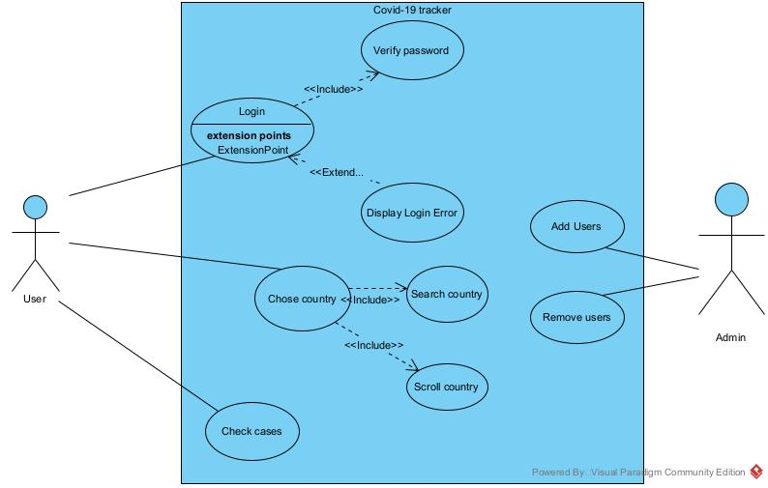

Figure 5 Use case diagram

#### 3.5.2 Data Flow Diagram

A data flow diagram is a graphical visualization for depicting the flow of data in an information system.

Context level dataflow diagram.

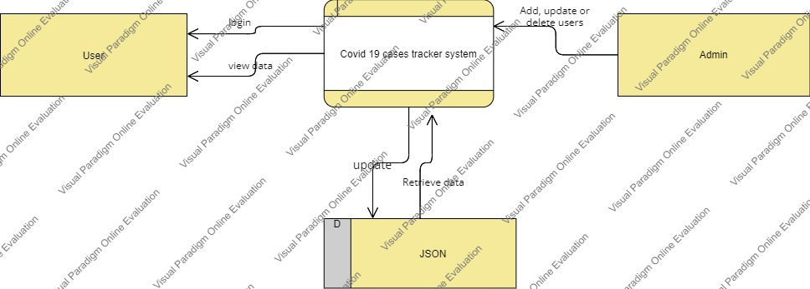

Figure 6 Context level diagram

#### 3.5.3 Activity Diagram

The user first login by putting a password and if authenticated he/she proceed to select menu otherwise if password is incorrect; it’s terminated or retry by putting the correct password.

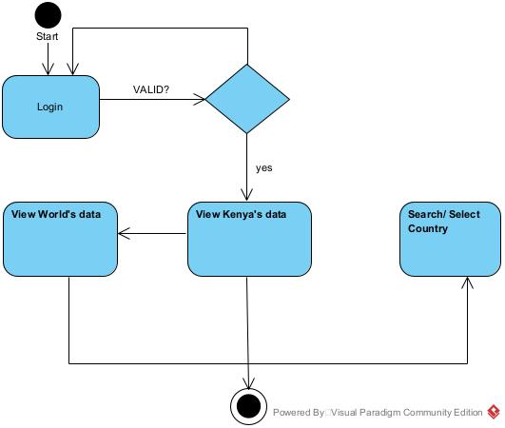

Figure 7 Activity Diagram

#### 3.5.4 Database Design

Database is modeled using Firebase real time Database. Database is a critical point to a system because this is where all the data related to the system is saved. The designed database is normalized to avoid redundancies

It is designed using the Entity Relationship diagram as below:

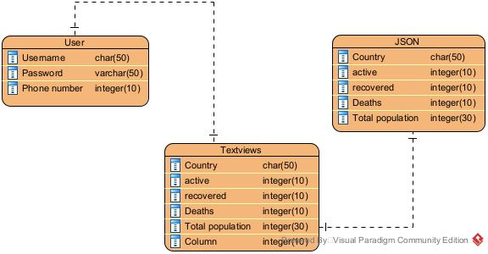

Figure 8 Entity relation diagram

# CHAPTER 4

## METHODOLOGY

### INTRODUCTION

A methodology refers to the framework that is used to structure, plan, and control the process of developing an information system. It is also a system of principles from which specific methods may be derived to interpret or solve different problems in different fields. A wide variety of such frameworks have evolved over the years, each with its own recognized strengths and weaknesses. One system development methodology is not necessarily suitable for use by all projects. Each of the available methodologies is best suited to specific kinds of projects, based on various technical, organizational and project considerations. Unlike an algorithm a methodology is not a formula but a set of practices.

### AGILE METHODOLOGY

Agile methodology is an alternative to waterfall methodology. The system goes through a series of iterations, analyzing, designing, developing and testing each feature in turn within the iterations. In an agile paradigm, every aspect of development — requirements, design, etc. — is continually revisited throughout the lifecycle. It provides opportunities to assess the direction of a project throughout the development lifecycle.(Turk, France, & Rumpe, 2014)

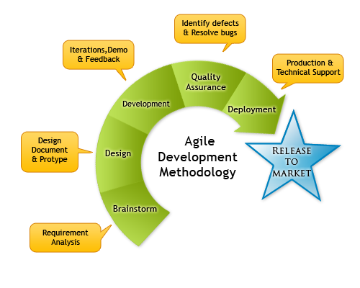

Figure 9 Agile Methodology Diagram

**4..2.1 Methodology justification**

Agile is based on the adaptive software development methods. Tasks are divided to small time frames to deliver specific features for a release. As Opposed to Traditional software development modelling tools Agile is a software development model which believes that every project needs to be handled differently and the existing methods need to be tailored to best suit the project requirements. Iterative approach is taken and working software build is delivered after each iteration. Each build is incremental in terms of features; the final build holds all the features required by the customer. Customer interaction is the backbone of Agile methodology, and open communication with minimum documentation are the typical features of Agile development environment. Its main advantages include:

1. Iterative approach is taken and working software build is delivered after each iteration. Each build is incremental in terms of features; the final build holds all the features required by the customer. Customer interaction is the backbone of Agile methodology, and open communication with minimum documentation are the typical features of Agile development environment. Its main advantages include: Is a very realistic approach to software development
2. Functionality can be developed rapidly and demonstrated.
3. Resource requirements are minimum.
4. Delivers early partial working solutions and promotes teamwork and cross training.
5. It is suitable for changing environments and good model for environments that change steadily.
6. Minimal rules, documentation easily employed.
7. Gives flexibility to developers.
8. **Requirements planning phase**

In this phase, the system requirements are collected as much details as possible (Rouse, 2009). There are a lot of methods to gather user requirement such as through interview, active observation, distribute questionnaires and conduct a workshop (Liles, 2012). In order to get user requirement, active and passive observation methods is used for this project. Active observations must be carried out so as to get feedback and gauge the views of the participants and are easily noted down.

1. **User design phase**

In this phase, the system and software design were prepared from the requirement specifications which were studied in the first phase. System Design helps in specifying hardware and system requirements and also helps in defining overall system architecture. The system design specifications serve as input for the next phase of the model.

1. **Development**

This stage is not distinct. It may involve several iterations during the phase. There is a backlog in which adjustments and new requirements are added during the development phase. First initial functionality is delivered where the system is reviewed by the stakeholders in order to identify any inadequacy and incorporate changing requirements. This makes agile development more flexible compared to waterfall and ensuring higher success rates.

1. **Testing**

In system testing the behavior of whole system/product is tested as defined by the scope of the development project or product. It includes tests based on risks and/or requirement specifications, business process, use cases, or other high-level descriptions of system behavior, interactions with the operating systems, and system resources. System testing also investigated both functional and non-functional requirements of the testing.

1. **Deployment**

After the system pass the testing phase and is operationally satisfactory it was released to the users.

# CHAPTER 5

## 5.0 IMPLEMENTATION

In this chapter the implementation of the system is being discussed. Implementation is the process of converting system design into the real-world system which can be used in day-to -day business tasks. This is a critical task in developing a system and where most of the time consumes.

According to the system requirements, developers have the ability to choose tools and techniques which are more familiar to them for implementing the project. The developer should take care of the task that the program codes are accurate and readable

### 5.1 IMPLEMENTATION ENVIRONMENT

|  |  |
| --- | --- |
| **Hardware** | **Software** |
| * Intel Core i3 processor 2.53 GHz * 6 GB RAM and above * 320 GB Hard Disk and above | * Microsoft Windows 10 PRO * Android studio * Firebase Realtime Database |

#### 5.1.1 Development Tools

* Firebase Realtime Database.
* Firefox and other web browsers for getting images that were fed to the system
* Lucid Chart app for UML designing for documentation
* Microsoft Word for typing the documentation

#### 5.1.2 Technology

* Java as the main development language used in the system.
* Firebase real-time database for storing user’s data
* Android studio IDE for developing the application.

### NETWORK IMPLEMENTATION

Since the system is an android application, it can be installed on an android handset where anyone can check on the status of Covid-19 cases for any country of choice at the convenience of their palms.

The system requires a connection to the firebase real-time database to register and authenticate a user and also within the system itself requires internet connection to access the data or refresh from the JSON file.

### SYSTEM SECURITY

The system contains a minimal amount of personal information thus security not made an emphasis but users require to be authenticated to keep track on the number of users.

When logging into the system a user is required to key in their Email and password. The Email and Password are checked with the database.

# CHAPTER 6

## EVALUATION

Evaluation is where the system is tested. System testing can be done in several ways. Evaluation holds critical role when it comes to quality of the system because the system should do the expected task without any errors. This is a two-step process which is verification and validation. **Validation** is the process of determining whether a fully developed system conforms to its requirement specification. **Verification** is the process of determining whether the output of one phase of a software development conforms to that of previous phase. Testing is done in several stages of the system to reduce errors.

Once errors have been identified in a program code, it is necessary to first identify the precise program statement responsible for the error and then fix them.

Testing is a process, which reveals errors in the program. It is the major quality measure employed during software development. During software development. During testing, the program is executed with a set of test cases and the output of the program for the test cases is evaluated to determine if the program is performing as it is expected to perform.

### 6.1 TESTING STRATEGIES

In order to make sure that the system does not have errors, the different levels of testing strategies that are applied at differing phases of software development are:

#### 6.1.1 UNIT TESTING

Unit Testing is done on individual modules as they are completed and become executable. It is confined only to the designer's requirements. Each module can be tested using the following two strategies:

1. **Black Box Testing**

In this strategy some test cases are generated as input conditions that fulsly execute all functional requirements for the program. This testing has been uses to find errors in the following categories:

* Incorrect or missing functions
* Interface errors
* Performance errors
* Initialization and termination errors.

1. **White Box Testing**

In this the test cases are generated on the logic of each module by drawing flow graphs of that module and logical decisions are tested on all the cases. It has been uses to generate the test cases in the following cases

* Guarantee that all independent paths have been Executed.
* Execute all logical decisions on their true and false Sides.
* Execute all loops at their boundaries and within their operational bounds

**5.5.2 INTEGRATION TESTING**

Integration testing ensures that software and subsystems work together a whole. It tests the interface of all the modules to make sure that the modules behave properly when integrated together. Integration testing (sometimes called integration and testing, abbreviated I&T) is the phase in software testing in which individual software modules are combined and tested as a group. It occurs after unit testing and before validation testing. Integration testing takes as its input modules that have been unit tested, groups them in larger aggregates, applies tests defined in an integration test plan to those aggregates, and delivers as its output the integrated system ready for system testing.

**5.5.3 SYSTEM TESTING**

It Involves in house testing of the entire system before delivery to the user. Its aim is to satisfy the user the system meets all requirements of the client's specifications. System testing of software or hardware is testing conducted on a complete, integrated system to evaluate the system's compliance with its specified requirements. System testing falls within the scope of black-box testing, and as such, should require no knowledge of the inner design of the code or logic.

As a rule, system testing takes, as its input, all of the "integrated" software components that have passed integration testing and also the software system itself integrated with any applicable hardware system(s). The purpose of integration testing is to detect any inconsistencies between the software units that are integrated together (called assemblages) or between any of the assemblages and the hardware. System testing is a more limited type of testing; it seeks to detect defects both within the "inter-assemblages" and also within the system as a whole.

**5.5.4 ACCEPTANCE TESTING**

It is a pre-delivery testing in which entire system is tested at client's site on real world data to find errors. Acceptance testing is a test conducted to determine if the requirements of a specification or contract are met. It may involve chemical tests, physical tests, or performance tests. In systems engineering it may involve black-box testing performed on a system (for example: a piece of software, lots of manufactured mechanical parts, or batches of chemical products) prior to its delivery.

In software testing the ISTQB defines acceptance as: formal testing with respect to user needs, requirements, and business processes conducted to determine whether a system satisfies the acceptance criteria and to enable the user, customers or other authorized entity to determine whether or not to accept the system. Acceptance testing is also known as user acceptance testing (UAT), end-user testing, operational acceptance testing (OAT) or field (acceptance) testing.

Testing can be done in two ways:

* Bottom-up approach
* Top-down approach

**Bottom-Up Approach:** Testing can be performed starting from smallest and lowest level modules and proceeding one at a time. For each module in bottom up testing a short program executes the module and provides the needed data so that the module is asked to perform the way it will when embedded within the larger system. When bottom level modules are tested attention turns to those on the next level that use the lower-level ones they are tested individually and then linked with the previously examined lower-level modules.

**Top-Down Approach:** This type of testing starts from upper-level modules. Since the detailed activities usually performed in the lower-level routines are not provided stubs are written. A stub is a module shell called by upper-level module and that when reached properly will return a message to the calling module indicating that proper interaction occurred. No attempt is made to verify the correctness of the lower-level module.

The important test cases will be found on appendices.

# CHAPTER 7

## 7.0 FUTURE ENHANCEMENTS, RECOMMENDATIONS AND CONCLUSION

## 7.1 FUTURE ENHANCEMENTS

Some enhancements supposed to be made for this project includes;

* **Application should support IOS users.**

In order for the application to be used on a wider scale, it should be integrated to support IOS users.

* **Geofencing and Movement monitoring**

The application should be upgraded to support monitoring of movement user and offer Geolocating and warning of potential of Hot area zones with the highest rate of infections to support protection of users.

## 7.2 RECOMMENDATIONS

The android application should be able to arrange data in the county level in Kenya so as to support future features like geofencing and to make the data more accurate. The project should have a more well defined JSON data set that is more reliable so as to retrieve data more efficiently and more accurately. Also, an IOS version of the application should be developed to support IOS phone users.

## 7.3 CONCLUSIONS

This project was developed by a Kenyan student, therefore more emphasis id taken into consideration concerning the useability of Kenyans in the design of the application. The system is automated thus require minimum human intervention to function. The JSON data set from where the data is derived from contains data updated from all over the world and it is updated twice a day.

The system is developed using Java as the base programming language and used Android studio IDE for the development task. The system design was carried out using UML (UNIFIED MODELLING LANGUAGE) as a tool for designing. Firebase real time database was used as authentication mechanism and to monitor users.

## 7.4 LESSON LEARNT

The knowledge gained through the project was worthy. With respect to the knowledge gained throughout the degree program by every module of study this is where I got the chance to apply my theoretical knowledge into real work problem.

This project helped me to gain knowledge regarding Android application development process. It also needed me to dig into some areas which are not covered by the course modules taught which led me to practice how an unknown problem to me can be solved with the research.

Further working on the project helped me to develop technical skills in JAVA, Firebase real-time database and android application design. Also, the project helped me a lot in developing my communication skills by collaborating with many individuals from collective fields.

# REFERENCES

1. (n.d.). WHO Coronavirus (COVID-19) Dashboard. <https://covid19.who.int/>
2. COVID-19 map. (n.d.). Johns Hopkins Coronavirus Resource Center. <https://coronavirus.jhu.edu/map.html>
3. Kamel Boulos MN. Descriptive review of geographic mapping of severe

acute respiratory syndrome (SARS) on the internet. Int J Health Geogr.

2004;3(1):2. https ://doi.org/10.1186/1476-072X-3-2.

1. U.S. Centres for Disease Control and Prevention (CDC). 2019–2020 U.S. Flu

Season: Preliminary Burden Estimates. https ://www.cdc.gov/flu/about /

burden/preliminary-in-season-estimates.htm.

1. Public Health England. Weekly national flu reports: 2019 to 2020 season.

https ://www.gov.uk/government /statistics /weekly-national-flu-reports-2019-to-2020-seaso n.

1. Koch T. Plague: Bari, Naples 1690–1692. In: Koch T, editor. Cartographies

of disease: maps, mapping and medicine. Redlands: Esri Press; 2005. p.

19–24.

# CHAPTER 8

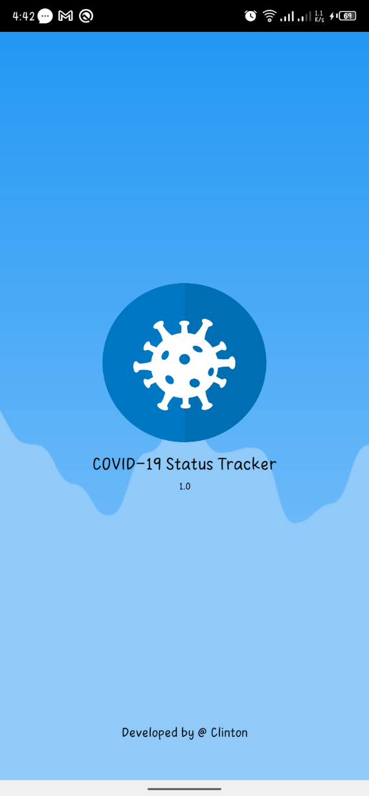**APPENDICES**

Figure 10 Splash screen

**Welcome / Splash Screen**

Once the application is started on the android devices the splash screen is the first activity that will appear when the application is still loading.

**Registration**

This enables Users to register using their credentials so as to be able to access the application. The credentials include Name, Email, Phone Number and password.

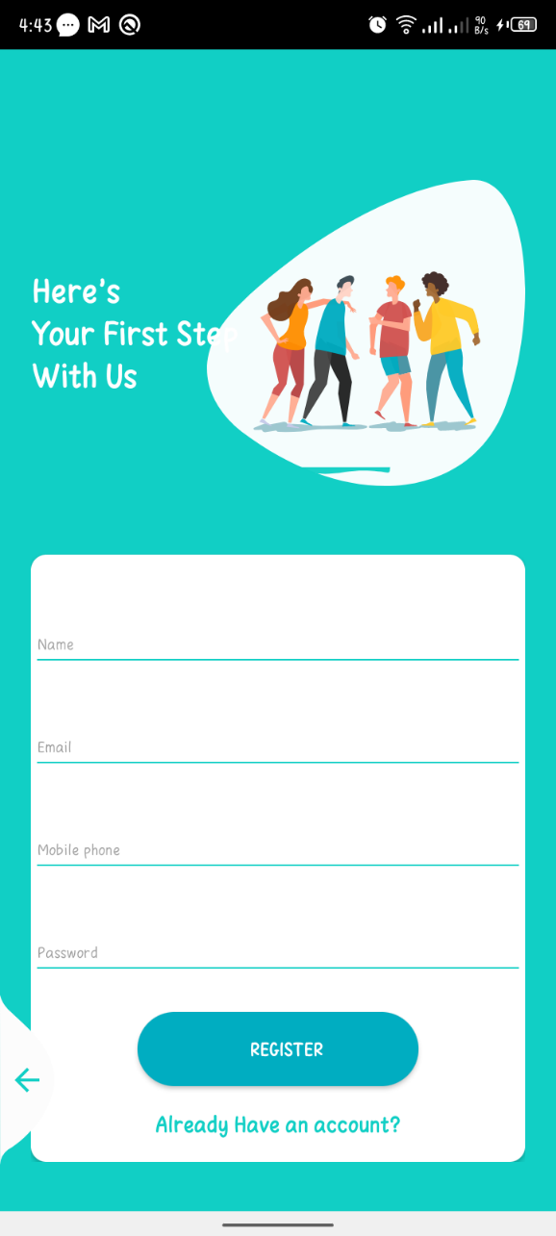

Figure 11 Registration

**Login**

Registered users need to be authenticated before using the applications thus on the login page they are required to key in their email they used to register and the password.

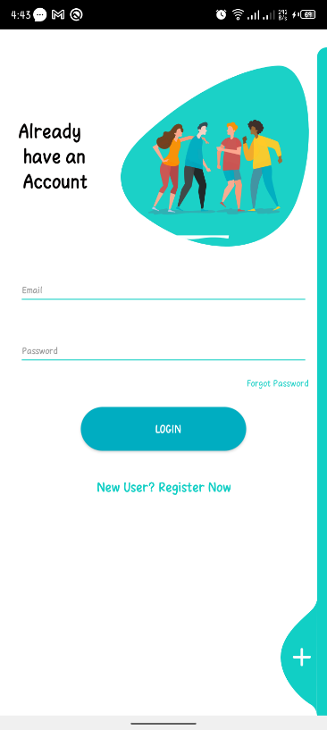**Kenyan Dashboard**

Figure 12 Login

After Login the first page is the Kenyan Cases Dashboard that displays Covid-19 related cases in Kenya. The first item is a pie chart representation that shows a graphical representation of Active cases, Death cases and Recovered cases. The rest of information is arranged in textviews including:

* Total Population
* Total Confirmed cases
* New Confirmed cases
* Recovery cases
* New Recovery cases
* Total Deaths
* New Deaths
* Total Samples tested
* Critical cases

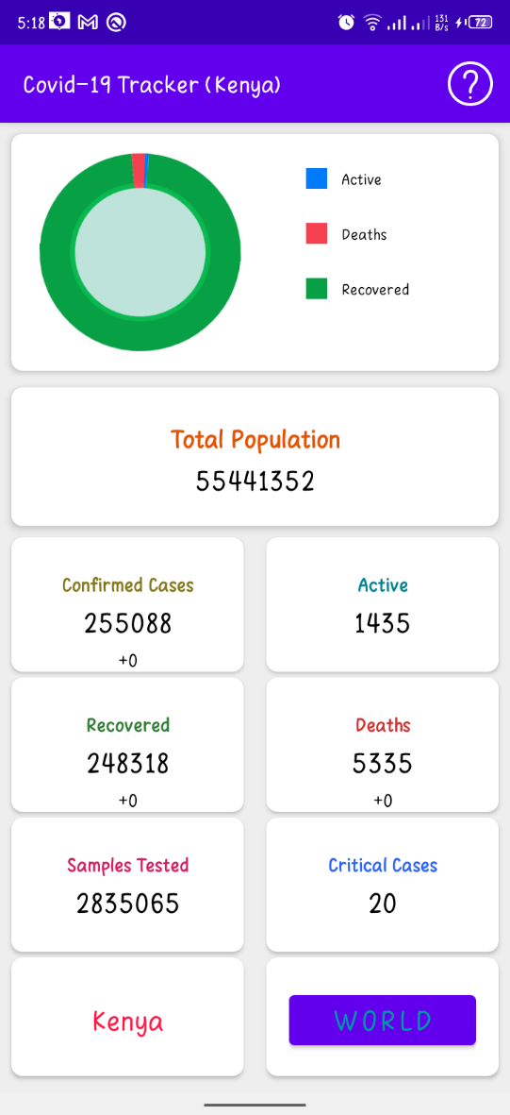

Figure 13 Kenya's dashboard

**About**

This page gives brief information concerning the application and the developer and the libraries used by the application.

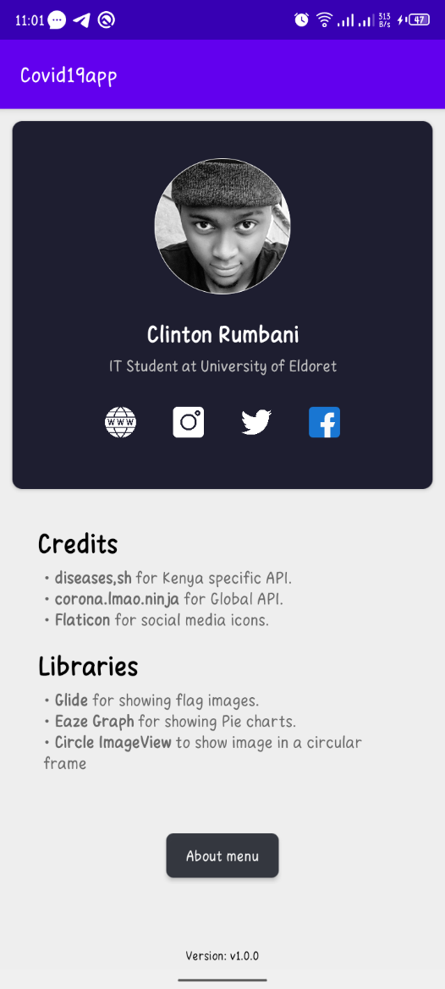

Figure 14 About

**World Dashboard**

Displays information concerning the world related to Covid-19. It shows:

* Total Confirmed cases
* New Confirmed cases
* Recovery cases
* New Recovery cases
* Total Deaths
* New Deaths
* Total Samples tested
* Critical cases

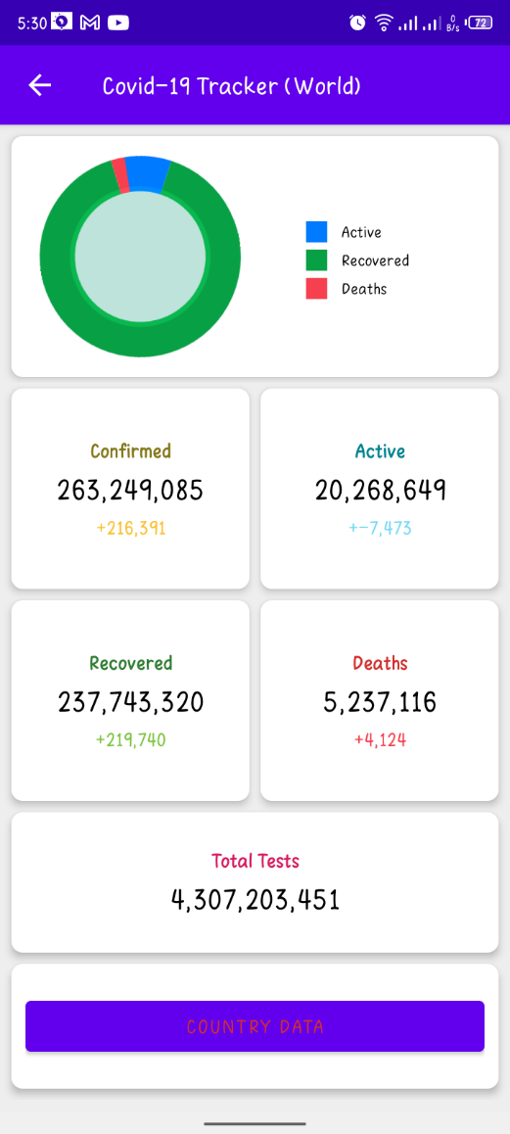

Figure 15 World's dashboard

**Specific Country Selection Dashboard**

This Dashboard allows users to either select a country by scrolling through the countries arranged according to the country with highest Covid-19 cases or by manually searching the country of choice on the search bar.

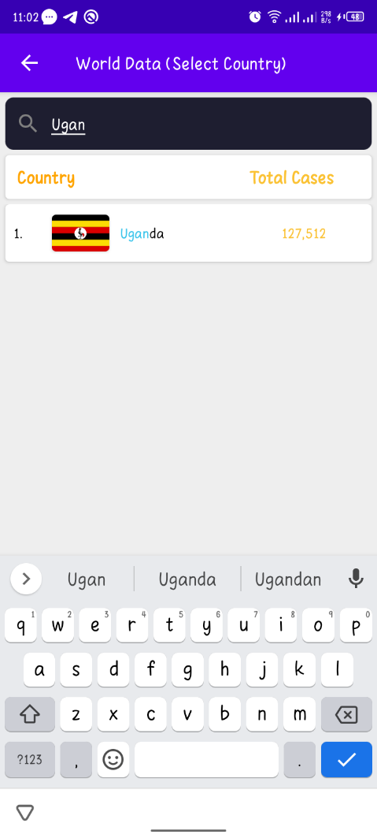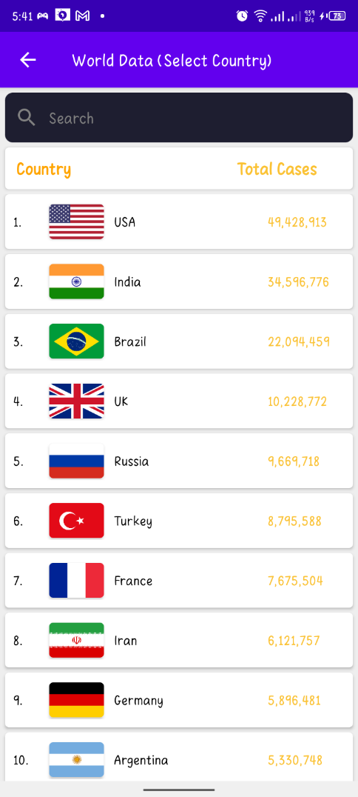

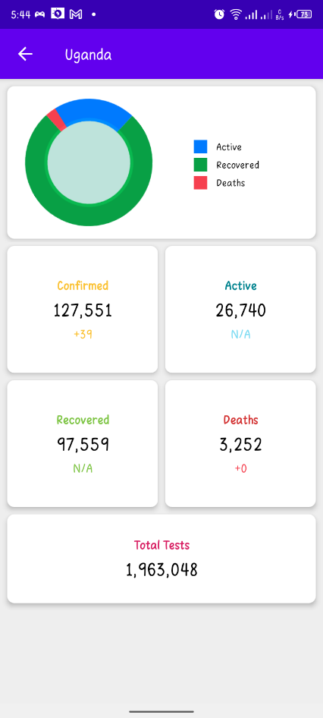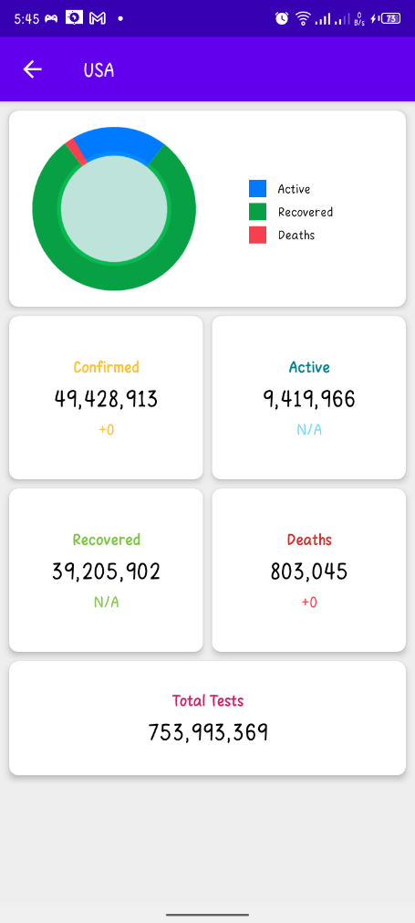

Figure 16 Search cases data

**GOD BLESS YOU.**